 | 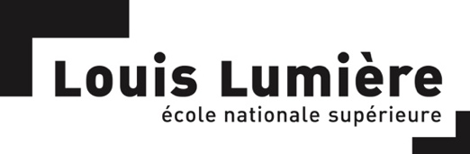 |  | Candidate photo

Summer programme 2023

École nationale supérieure Louis-Lumière
with the support of the
French Ministry for Europe and Foreign Affairs

July - August 2023

APPLICATION FILE

PERSONAL INFORMATION:

Surname:
First name:
Nationality:
Permanent Address:
Country/Region:

Street:

City:

State:
Postal Code:

Documentary podcast submitted at the TIFF (title and duration):

Personal situation:
Student
Name of the School / Department / Major
Year of study:

Young professional
Function:
Company:
Field of activity:

Other:

Date of birth:
Age:

Cell phone number: +

E-mail:
Skype:

Diploma:

Year | Diploma / Name of the school/university | Grade | Description

Other:
Year | Name of the school | Description | Duration

Professional experience:

Year | Name of the entity | Description (function)

YOUR INTEREST IN THIS WORKSHOP
Please note that these elements are meant to help the jury assess your familiarity with sound practices. However, this workshop will not be dedicated to carrying out this specific project.

- Do you listen to radio documentaries? If so, please specify which programs and where – radios, web radios, podcasts, festivals, etc.

- Do you currently have a radio / podcast project, or a creative project involving sound? If so, please provide a 1-page synopsis.

- In your opinion, what impact will your stay in France have on your professional career?

- How do you imagine your career in 5 years? Be precise.

YOUR LANGUAGE SKILLS
Assess your level, A1 being the weakest and C2 the strongest.
ENGLISH……. | A1/A2 | B1/B2 | C1/C2 | Bilingual
FRENCH…… | A1/A2 | B1/B2 | C1/C2 | Bilingual

Have you ever been to France? If so, why and for how long? Tourism, linguistic stay, studies?

Sound recording skills (specify equipment)
Equipment: ……….
Level | Very good | Good |  | Medium | Poor

Use of sound editing software (specify software)
Software: ……….
Level | Very good |  | Good | Medium | Poor

ATTENTION PLEASE

In addition to the above items, please provide the following documents:

- CV (1 page, in English)

- A cover letter (in English) explaining the various reasons why you are applying for this workshop (1 page)

- A 1-page synopsis of your current sound-based project (if relevant)

- An ID photo in digital format, to be inserted at the top of the initial page of this file.

- An English transcript of the podcast you submitted (unless it’s already in English).
It does not have to be a professional translation but must be as accurate as possible in order for the jury to assess the quality of your work.

All documents, including this form, must be filed as one pdf file in that order.

